Conv-LSTM-Conv network: a deep learning approach for sentiment analysis in cloud computing.

In this paper, the topic of interest is a Project to realize Sentiment Analysis S.A. in a dataset containing text of comments of some topic. Introducing us to the rapid development of all media, where now every person can share an opinion of everything.

Nowadays, a better way to analyze the opinions or reviews of any topic that has interaction with the users is searched, in order to study how users are interacting and their attitudes and feelings about these topics, these analysis could serve the purpose of enhancing these services or products that are being offered to the users.

In the introduction, we are presented some terms as N.L.P. (Natural Language Processing), S.A. (Sentiment Analysis) and text mining, and the main purpose, that is to get a binary classification of the opinions, based on deep learning algorithms with word embedding. And something interesting is that the authors share the architecture that is being used, being this a CNN layer, a LSTM (Long short-term memory) layer, and another CNN layer.

Also, there are some challenges in order to get the correct classification of the opinions, some of the mentioned are sarcasm, use of positive words to express bad emotions and word ambiguity.

Something I found interesting is the large amount of related works in this topic, where there are many different approaches to the S.A. using different techniques and technologies, where most of them are based on text features extraction as a first step to the full analysis.

The specific dataset used in this case is a movie reviews dataset, which has 1000 positive and 1000 negative reviews, dividing each category to training and test subsets.

Something important remarked in the paper, is that in order to get correct results in the classifications, we need to do some pre-processing of the data, for example in this cases, the authors mention that is important to remove incomplete sentences, incorrect grammar, imperfect words at first, what we could call “Noise reduction” and then we go to the actual data preparation, where in this case they used different types of filters, for character removal, stop words and short tokens, which basically uses just the most common words in each review.

This pre processing of data I think is one of the base parts of all the model, and involves a deep analysis out of all the computational topics, which means that we would need to consult an expert in the topic of our dataset, in order to get the correct and most important data actually in our model.

Then, the actual process is explained with multiple diagrams:

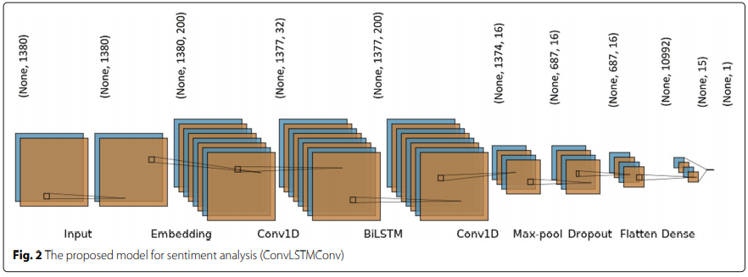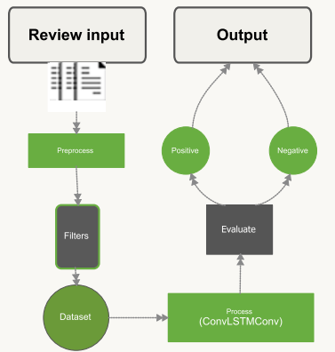

Where we can see the general and the specific diagrams, where the most interesting one is the specific model diagram, consisting in multiple different layers, and the text explains the function of each of those layers pretty good, giving the reader a good idea on the basic function.

Something else that the authors mention is that they tested two different architectures, being the last one the one that is represented in the diagram, in the first iteration they got an 83% accuracy in the test dataset, and then getting a 89% accuracy in the test dataset with the last iteration of design.

In the conclusion, the authors emphasize that further work is needed, first in the classification of more than just good bad emotions, because in real world there are different situations. And the fact that in the reviews there could be sarcasm and more higher level of languages that could be above the first pre-processing of data.